Train:

DDIM is faster than DDPM since DDIM doesn’t need to calculate the score function during training (DDIM directly use distribution of noise). it spares plenty of time for train.

Inference:

DDPM will sample a vector of noise and use diffusion process to generate images. On the other hand, DDIM directly sample noises from learned noise distribution. Without diffusion, it also makes inference of DDIM faster than DDPM.

Generate images:

However, without diffusion process, DDIM will generate blurrier image than DDPM, which can generate sharper image.

Why DDIM faster:

In conclusion, owing to the noise sampling and score function, DDIM is much faster than DDPM.

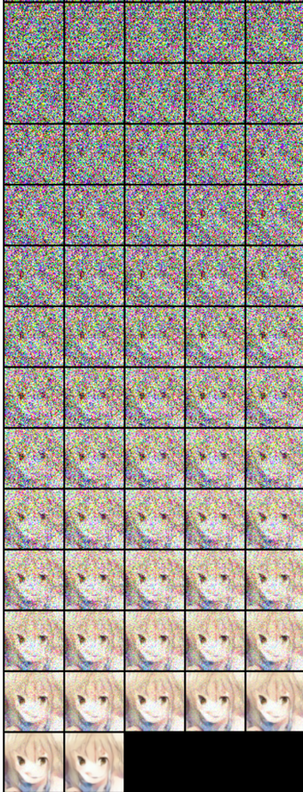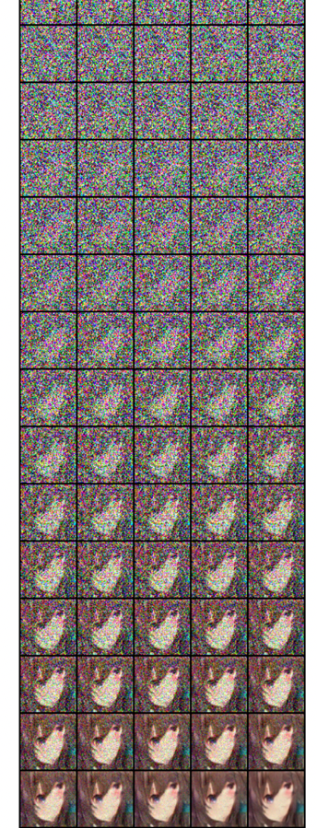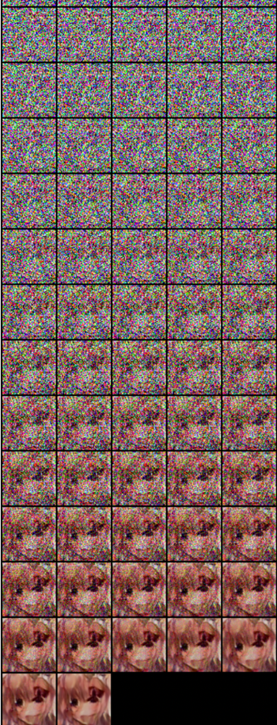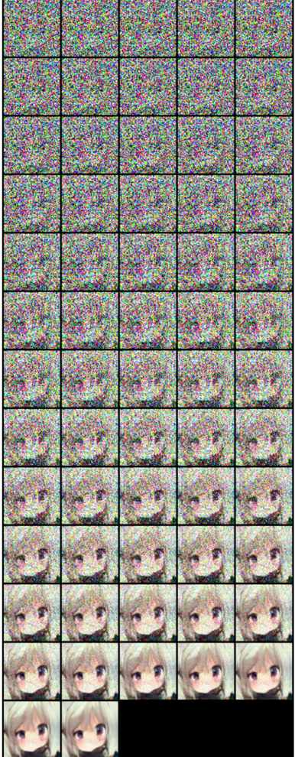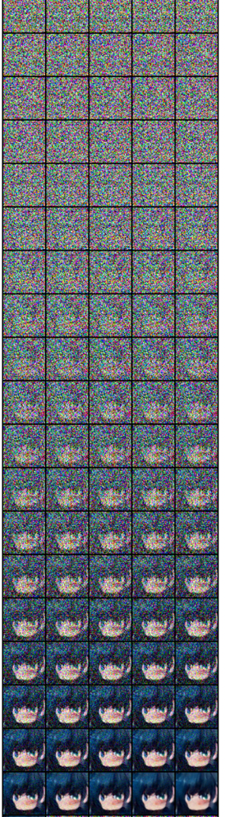

As we can see, the images are random dots of different color. With step becoming larger, we can observe the contour of face, but the dots still exist, and the images isn’t clear. In the end, dots disappear and we can see the faces, but it still have some flaw (some distortion on face).